Official league roster - Soccer
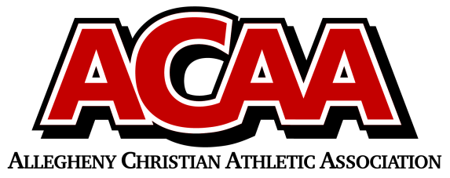

School Name: Great Commission Schools
Team Colors: Royal Blue/White
Overall Wins ___ Losses ____ Ties ___
ACAA Wins ___ Losses ____ Ties ___ OPPONENT: __________________________
Date: _________
Number | Name | Year | Position | Homeschool
1 | Kelsey Moyer | Senior | Striker
17 | Grace Baldwin | Senior | defense
14 | Mila Palazzi | Junior | Mid
4 | Bridgette Miller | Junior | striker
11 | Alanna Rice | Junior | striker | Yes
12 | Kira Suhoney | Junior | forward/mid | yes
16 | Gabriella Lawson | Junior | defense
22 | Lily Hildebrand | sophomore | defense
23 | Madeline Buck | sophomore | mid
13 | Jaden Grove | sophomore | defense
20 | Rachel Turiano | freshman | defense
10 | Michelle McConnell | freshman | mid
26 | Samara Wertz | freshman | defense
25 | Julianne VanProoyen | freshman | defense
88 | Kiera Wertman | freshman | defense
27 | Kayelynn Summers | freshman | mid
0 | Sophia Fleck | Eighth | goalie
15 | Melody Miller | Eighth | defense
8 | Marlow Schorner | eighth | mid | yes
7 | Trinity McConnell | Seventh | mid

Head Coach: dave Long
Asst. coach: Meghan stuart
Asst. coach: Israel Rosillo

Official ACAA League Team Roster. to be submitted to the scorer’s table before each game.

